**Project Report On**



**ZERO-E-WASTE**

Submitted in partial fulfillment for the award of

**Diploma in Advance Computing(E-DAC) from C-DAC, ACTS (Pune)**

**Guided by:**

**Mr. Kuldeep Singh**

# Presented by:

**Ms. Dipti Dilip Shipate PRN No. 210540181065**

**Ms. Shweta Dilip Adsul PRN No. 210540181201**

**Mr. Uday Sunil Bhoi PRN No. 210540181215**

**Mr. Vinay Kumar Sharma PRN No. 210540181223**

**Ms. Sushmita Balasaheb Magdum PRN No. 210540181208**

**Centre for Development of Advanced Computing (C-DAC), Pune**



**ACKNOWLEDGEMENT**

## This project “**ZERO-E-WASTE**” was a great learning experience for us and we are submitting this work to Advanced Computing Training School (CDAC ACTS).

We are very glad to mention the name of *Mr. Kuldeep Singh* for his valuable guidance to work on this project. His guidance and support helped me to overcome various obstacles and intricacies during the course of project work.

We are highly grateful to Ms. Risha P.R. (Manager (ACTS training Centre), C-DAC, for her guidance and support whenever necessary while doing this course Diploma in *Advanced Computing (E-DAC)* through C-DAC ACTS, Pune.

Our heartfelt thanks goes to *Mrs. Swati Salunkhe* (Course Coordinator, E-*DAC*) who gave all the required support and kind coordination to provide all the necessities and extra hours to complete the project and throughout the course up to the last day here in C-DAC ACTS, Pune.

**From:**

Ms. Dipti Dilip Shipate (210540181065)

Ms. Shweta Dilip Adsul (210540181201)

Mr. Uday Sunil Bhoi (210540181215)

Mr. Vinay Kumar Sharma (210540181223)

Ms. Sushmita Balasaheb Magdum (210540181208)

### TABLE OF CONTENTS

1. Introduction of Project
2. Product Overview and Summary
   1. Purpose
   2. Scope
   3. Overview
   4. Feasibility Study
3. Overall Description
   1. Product Feature
   2. Technology Used
   3. User Classes

3.3 General Constraints

1. Requirement
   1. Functional Requirements
   2. User Interface Requirements
2. Database Design
3. Test Report
4. Project Management Methodology
5. Future Scope

### Introduction of Project:

We have created an e-Waste web application where the user can sell different types of electronic waste.

Nowadays people face many difficulties whilexchil selling any e-waste material as they have to search many places or websites , which wastes a lot of time. The platform will provide sellers to sell those products by posting a sell request. User Interface, developed in React uses user email to authenticate and data is imported using REST. UI makes secure calls to Spring Boot. In the backend, JAVA is used to fetch and manipulate the data and used MySQL as database.

The Zero-e-waste is an application that allows users to sell various types of electronic Waste. Once the seller have given all the information, then admin will verify it and will allow or refuse the product. After request approval admin will send an agent to receive those products and the details of agent will be shared with the end-user. It provides facilities for adding, deleting, updating product request.

For all this a lot of API’s is used for the ease of user. API allows two applications to talk to each other and then the application interprets that data and presents the user with the information the user wanted in a readable way.

For the login of users into this website we use the user email authentication, which allows users to sign up with their email. This platform is based on REST services and it tends to independency of all services. This platform is rapid and frequent due to this technique.

### Product Overview and Summary

* 1. **Purpose:**

The e-waste management system is now an online e-waste management website. Public

will get the information about the e-waste material and aware others about it. We will

collect the e-waste equipments from the sellers and it will be delivered to recycling

companies with the help of agents.

### Scope:

An e-Waste web application where the user can sell different types of electronic waste.

### Overview:

Section 3.0, the Overall Description, provides an overview of the components and the relationship between them. Section 4.0 provides the Specific Requirements of the product. In the subsection (4.1) and (4.2) of which the various functional requirements and various interface respectively are discussed. Section 5.0 describes Database Design details.

### Feasibility Study

Feasibility is determination of whether a projects worth doing or not. Before actually recommending the new system it is important to investigate if it is feasible to develop the new system.

Before developing and implementing a system we have sure that our system is feasible in the following ways:

* **Technical Feasibility:**

In the type of feasibility study, the system analyst has to check whether it is possible or not to develop the requested system with availability of manpower, software, hardware, etc. The system which we run in Linux as well as windows platform and hence are suitable for the end- user. The system is technically feasible because it does not require too many resources and runs with the browser. A proof of concept was implemented to verify the technical feasibility to retrieve data from various APIs.

### Operational Feasibility:

In this type of feasibility study the operation implementation of the system is considered. Checking is done regarding whether it is feasible for the users to use the application. Thus the proposed system is said to be operationally feasible only of the end users are able to understand the system clearly and correctly and can use the system with ease and with the minimum training.

### Overall Description:

* 1. **Product Features**

The project's aim is to provide an e-Commerce website for plants which is containing java (platform independent), React, API’s for user.

### Technology Used BACK END

Spring Boot Hibernate.

MYSQL for storage of data.

### FRONT END

React

CSS

Bootstrap

Platform:

Web Development: J2EE Spring Boot, React, MySQL **J2EE Spring Boot**

Spring Boot has been built for Rapid Application Development. The goal of Spring Boot is to

provide a way to create Java applications quickly and simply, through an embedded server. By default, it used an embedded version of Tomcat and hence eliminating the need of Java EE containers.

It is a framework to ease the bootstrapping and development of new Spring Applications. Bootstrapping with defaults included in the configuration/ jar-dependencies. Easy to create standalone applications with embedded Tomcat/Jetty/Undertow. It provides defaults for code and annotation configuration to quick start new spring projects within no time. Plenty of Spring Boot Starter to quickly get up and running.

No code generation and no requirement for XML configuration. It reduces lots of development time and increases productivity.

**React**

React is a JavaScript library for building user interfaces. It has transformed the way we think about front-end development. React.js has clasped the engagement of the open-source community. And its demand is irreversible in the coming future. It is here to stay.

Improved performance: React uses Virtual DOM, thereby creating web applications faster. Virtual DOM compares the components’ previous states and updates only the items in the Real DOM that were changed, instead of updating all of the components again, as conventional web applications do.

**MySQL**

MySQL is an open-source relational database management system (RDBMS).A list of commonly used MySQL queries to create database, use database, create table, insert record, update record, delete record, select record, truncate table and drop table etc. MySQL is a relational database management system based on SQL – Structured Query Language. The application is used for a wide range of purposes, including data warehousing, e-commerce, and logging applications.

The most common use for MySQL, however, is for the purpose of a web database. It can be used to store anything from a single record of information to an entire inventory of available products for an online store. In association with a scripting language such as PHP or Perl (both offered on our hosting accounts) it is possible to create websites which will interact in real- time with a MySQL database to rapidly display categorized and searchable information to a website user.

### User Classes

There is two type of user which can access this website. One is customer and the second one is ADMIN which will manage the users, products and requests.

### General Constraints

Users must have an email and have a browser

### REQUIREMENTS

* 1. **FUNCTIONAL REQUIREMENTS**
     + **Complete System:**

**USER**

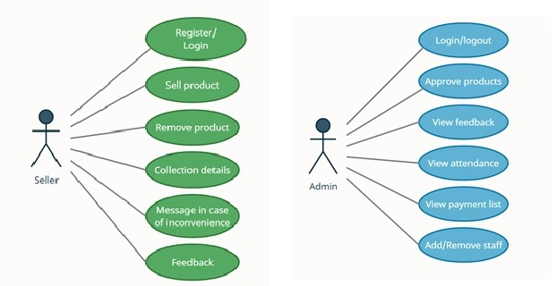

**4.2 USER INTERFACE REQUIREMENTS**



**Home Page**

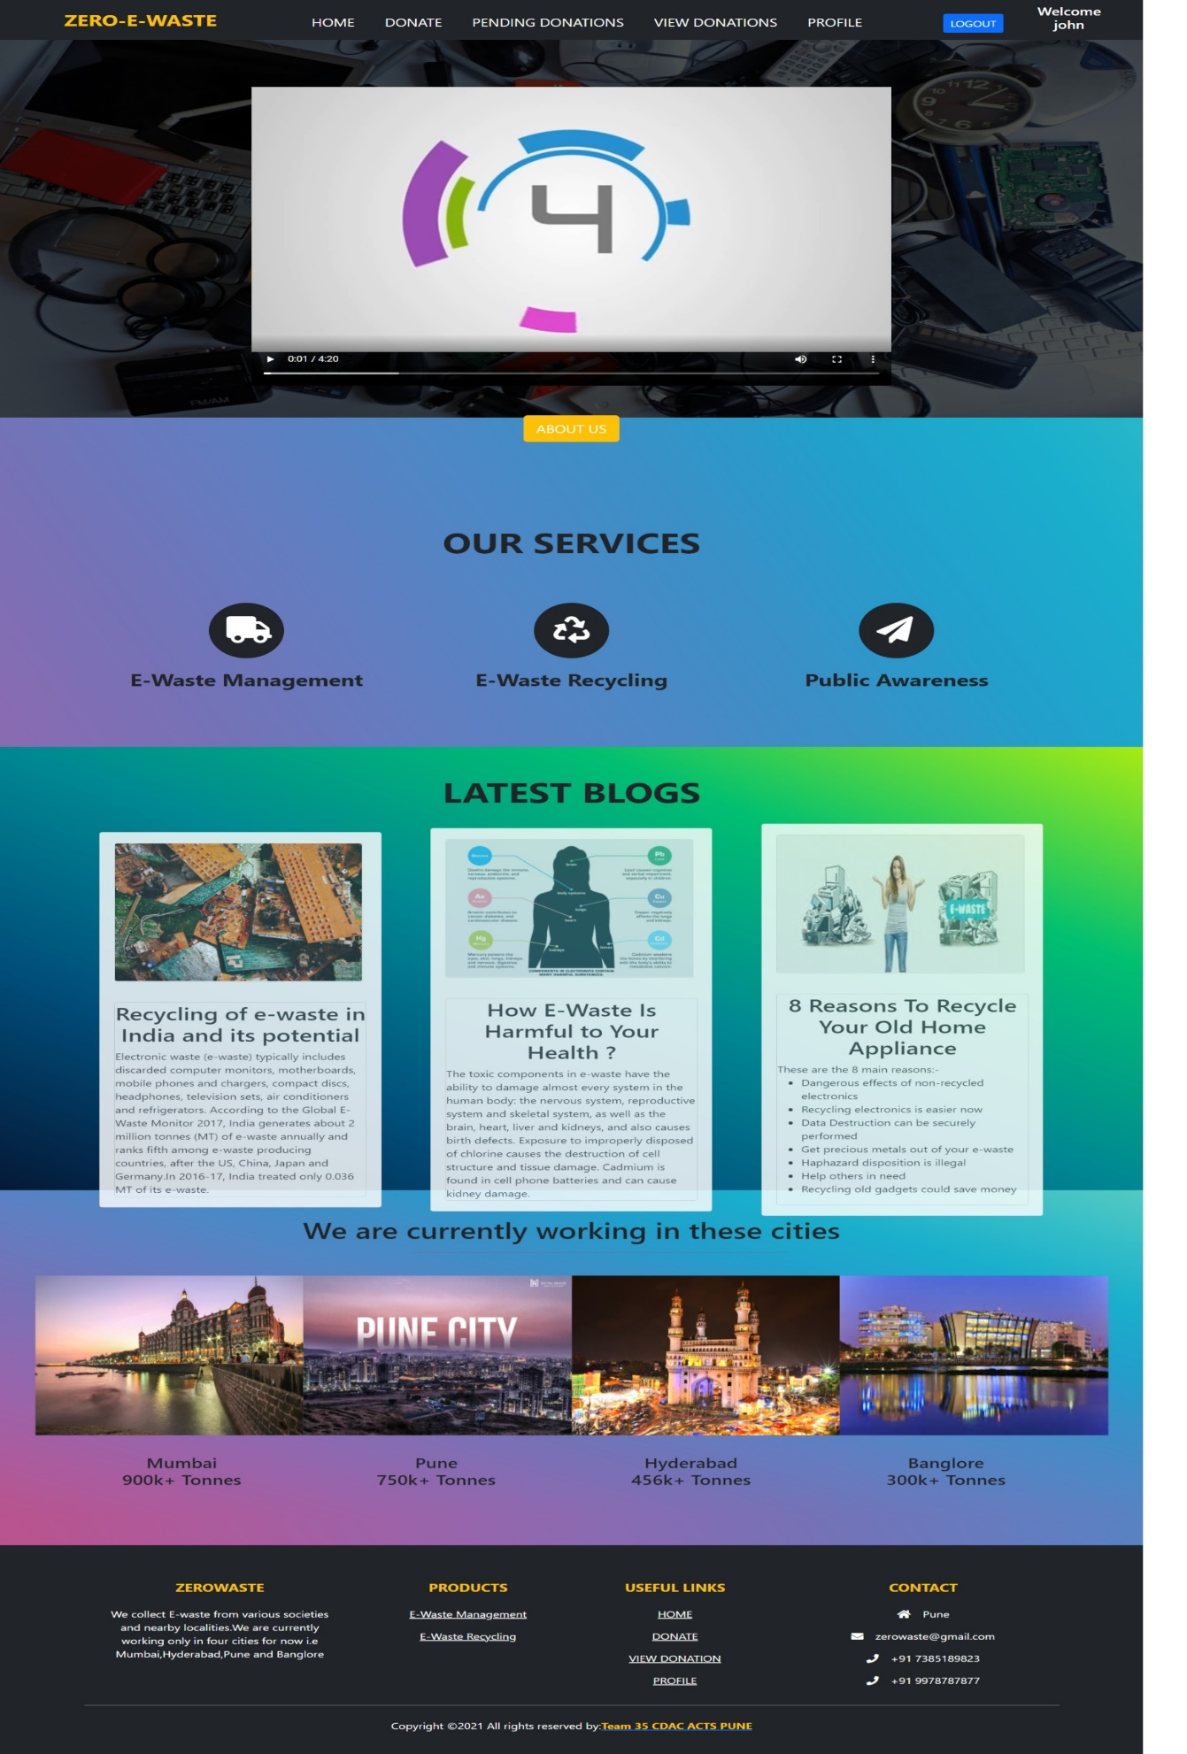

**DONATE PAGE**

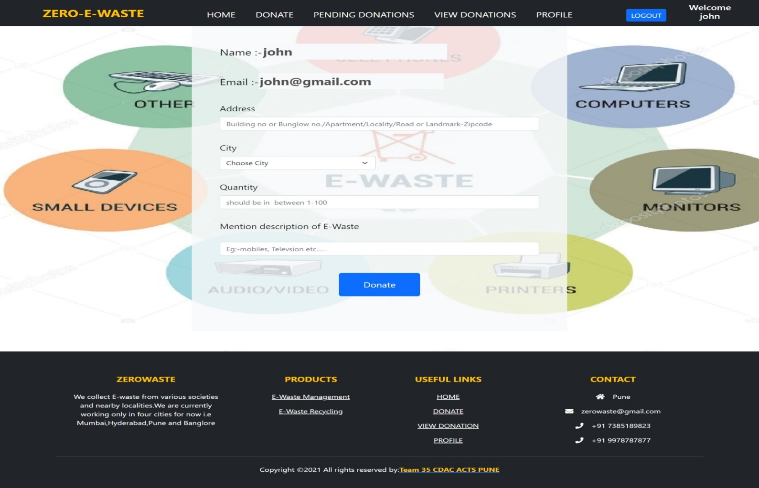

**PENDING DONATION PAGE**

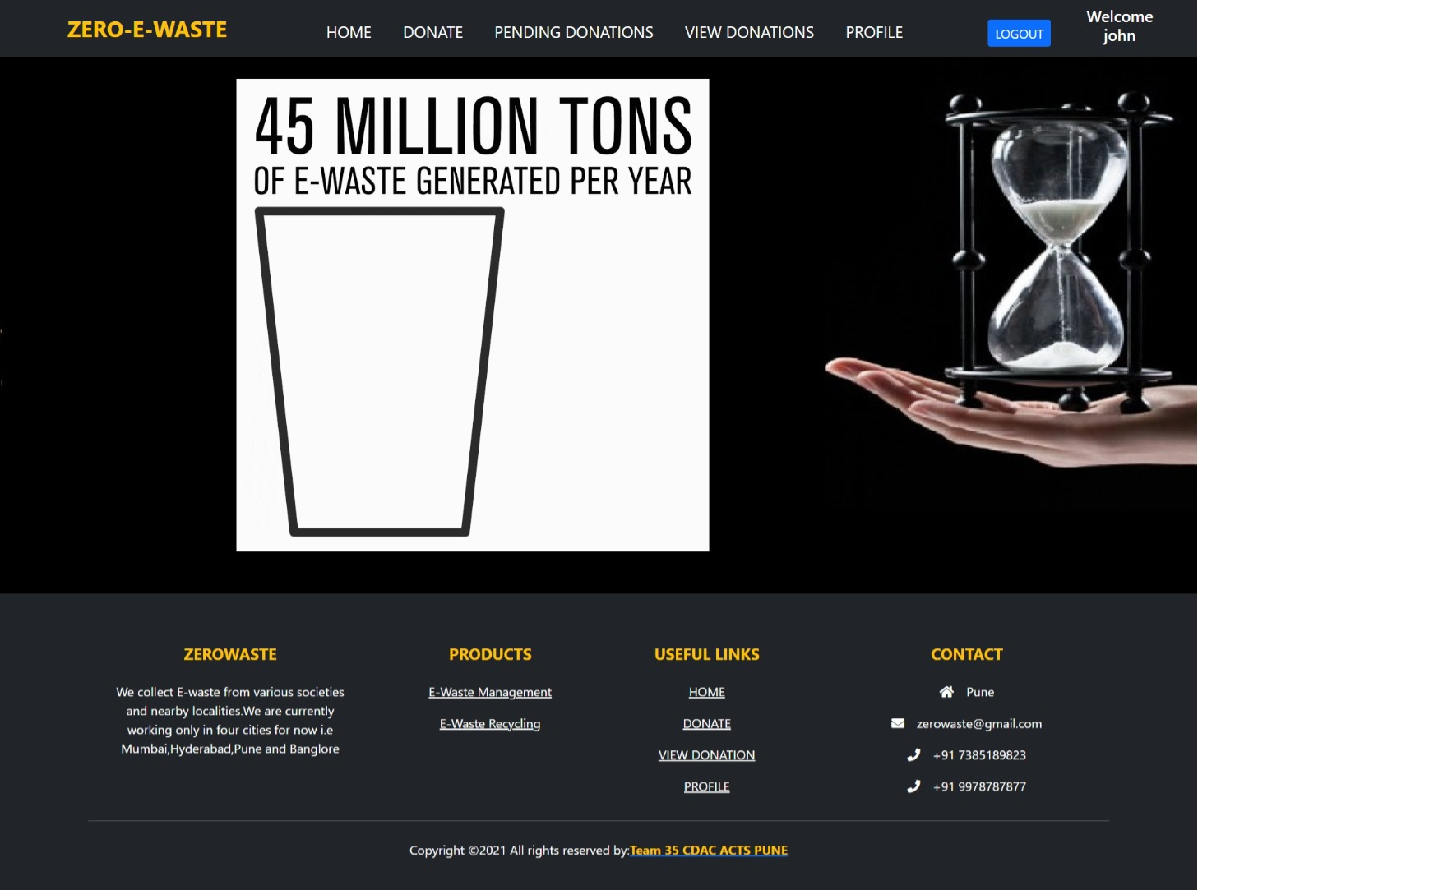

**VIEW DONATION PAGE**

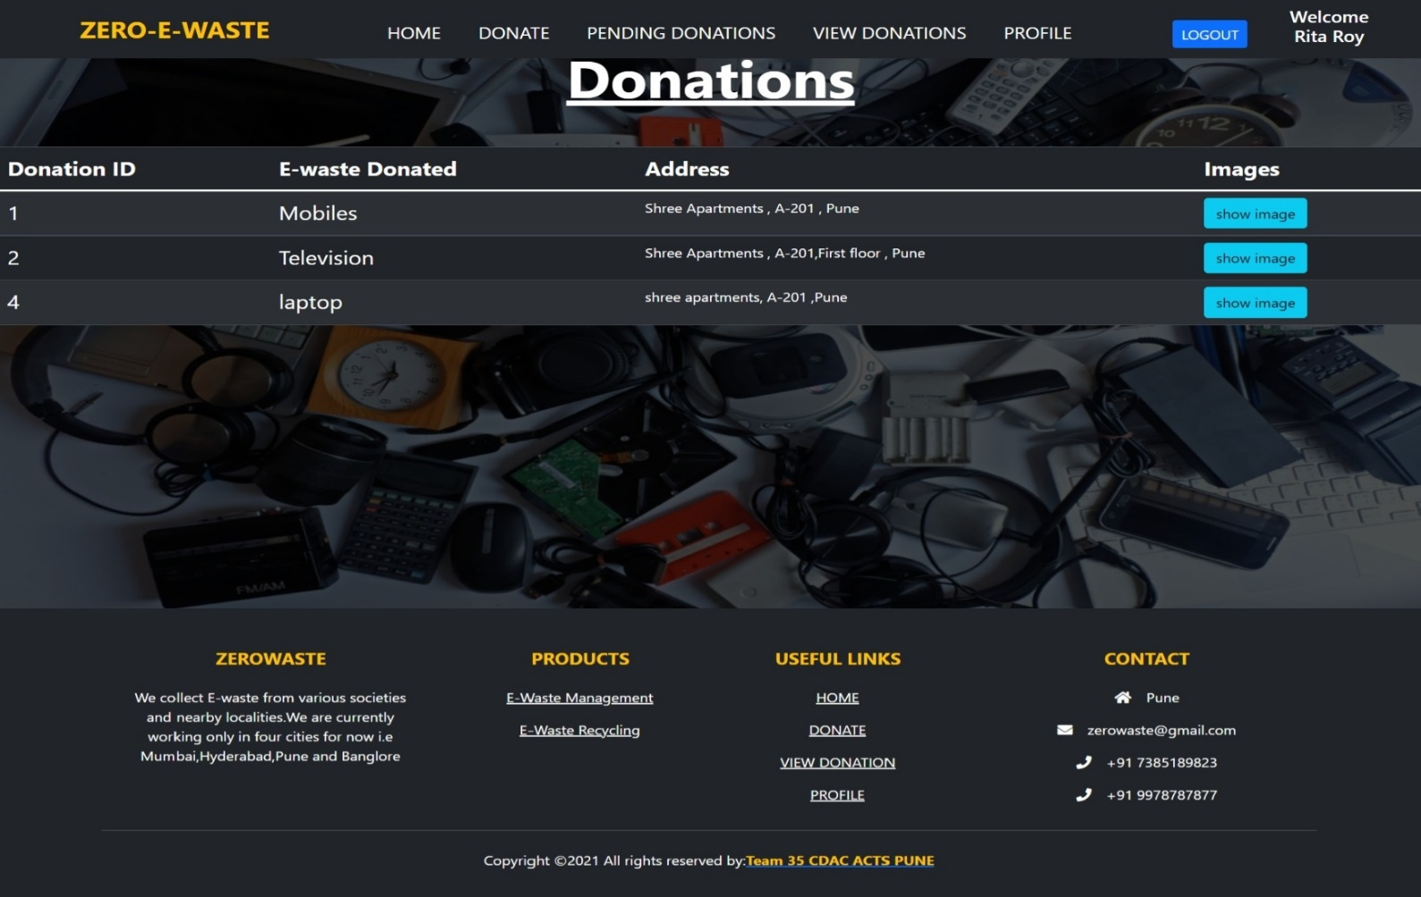

**VIEW DONATION PAGE**

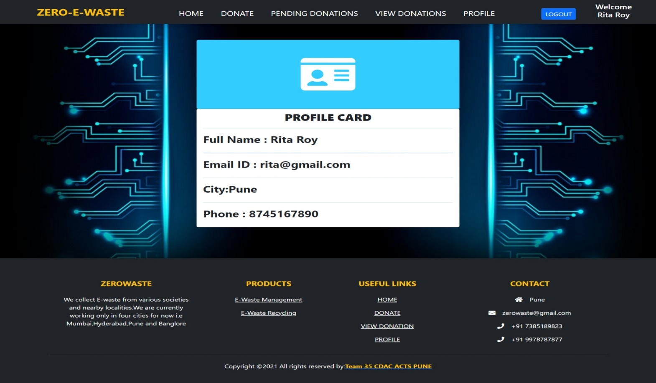

**LOG-IN PAGE**

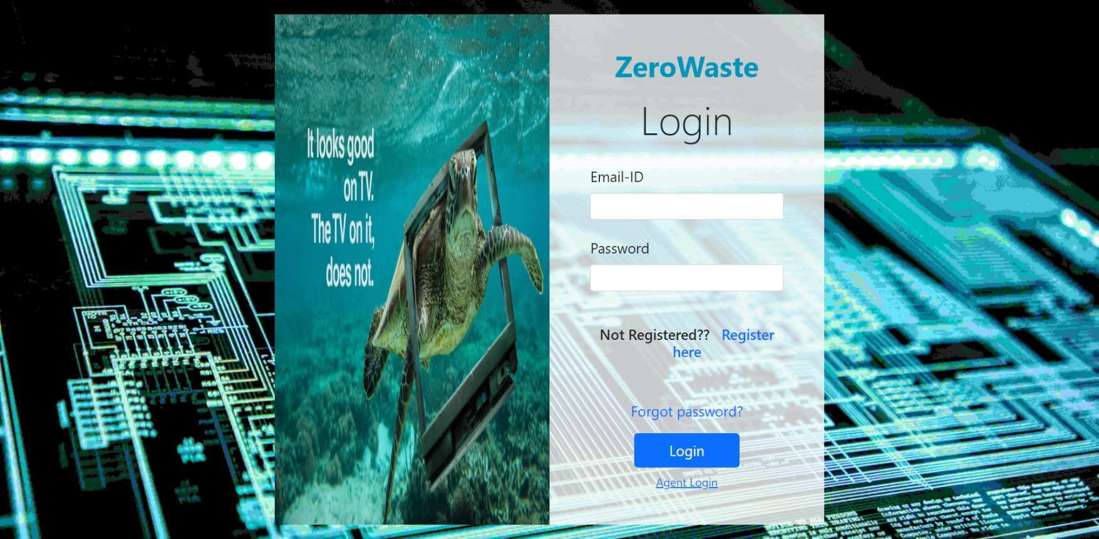

**REGISTER PAGE**

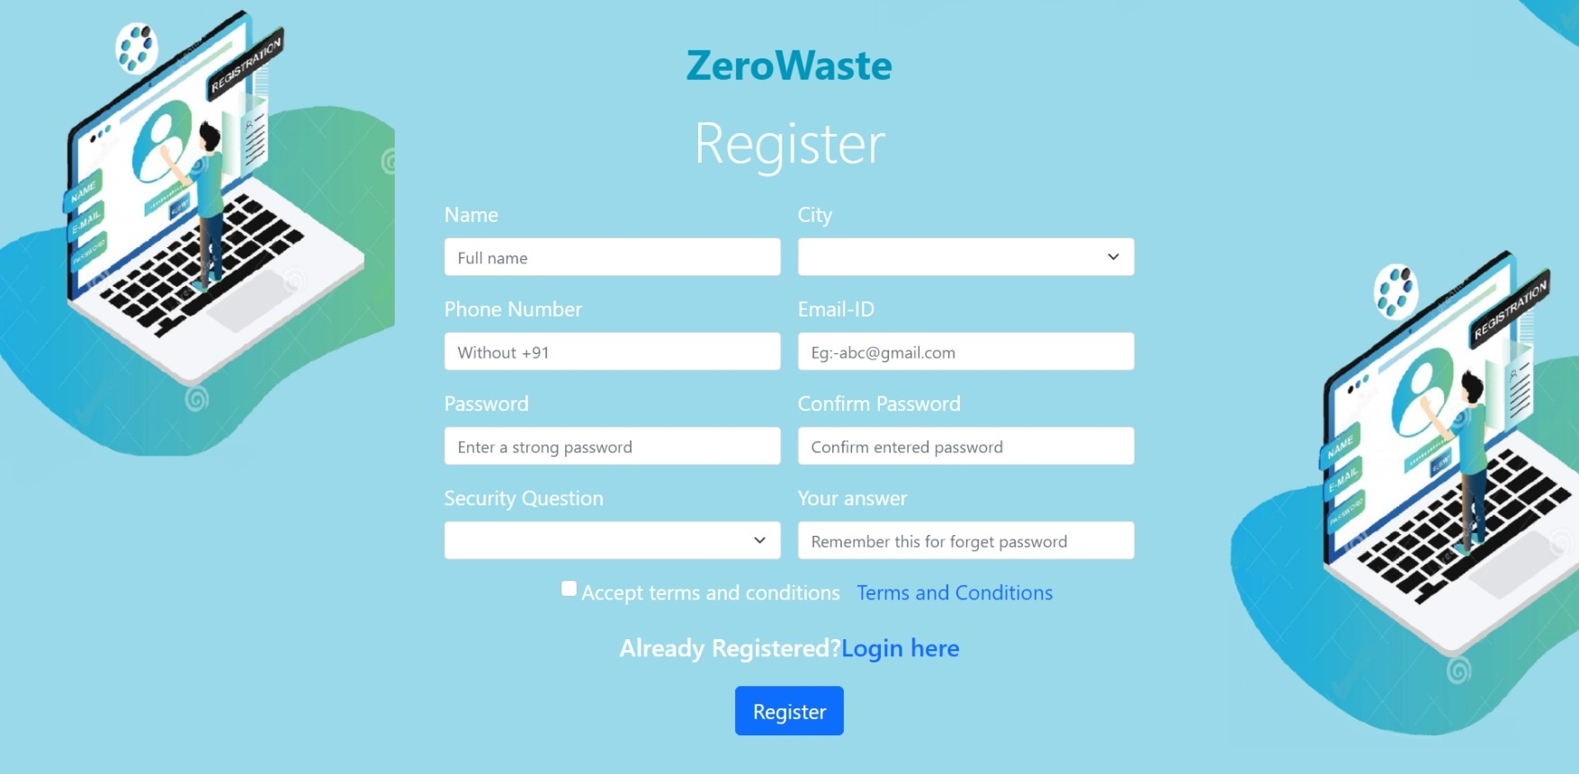

**ADMIN PAGE : (PENDING REQUESTS)**

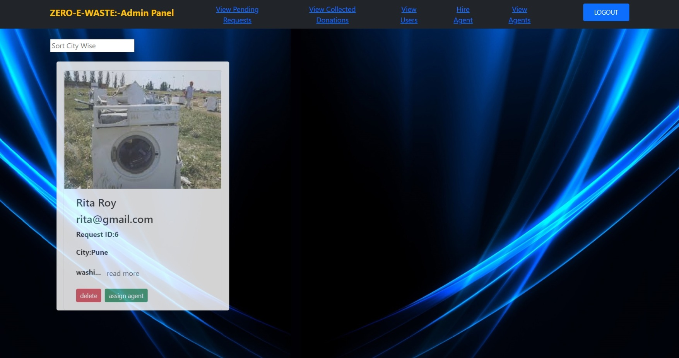

**ADMIN PAGE : (VIEW COLLECTED DONATIONS)**

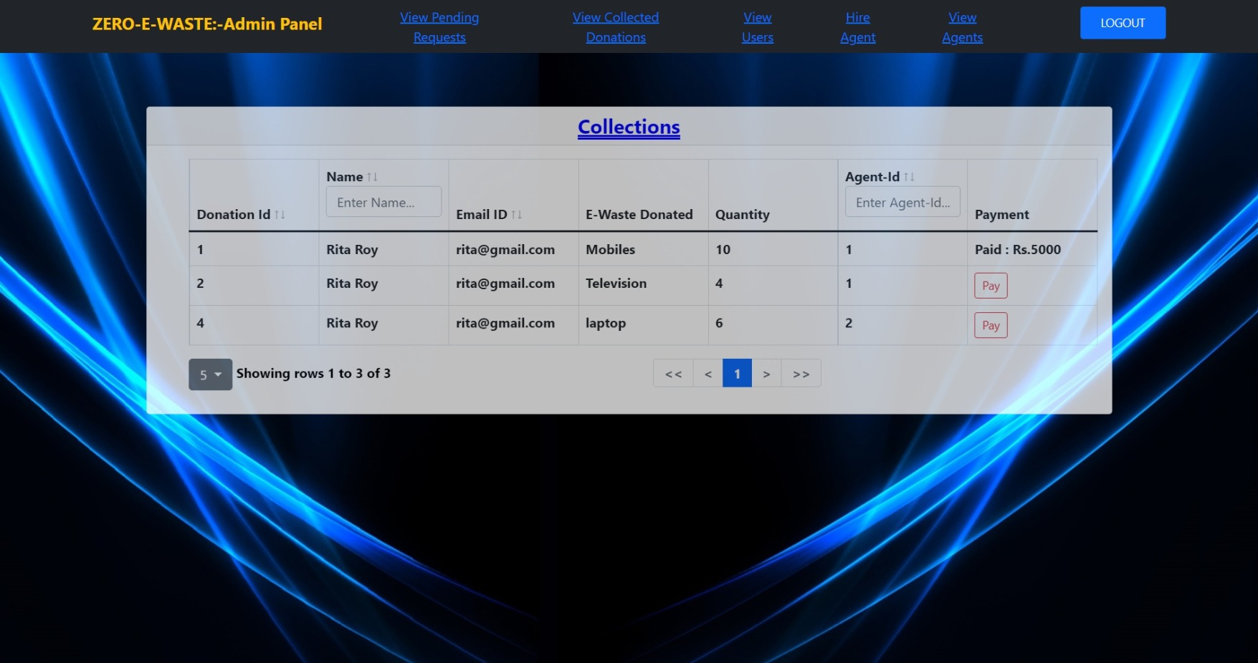

**AGENT HOME PAGE :**

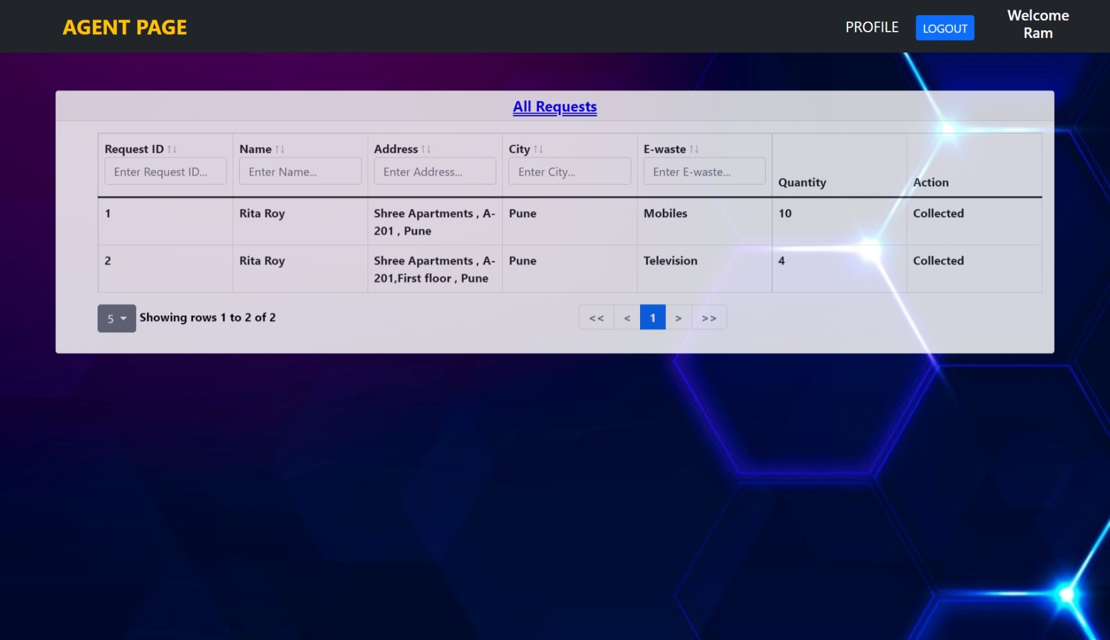

1. **Database Design**

The following table structures decipt the databse design.

### ER Diagram

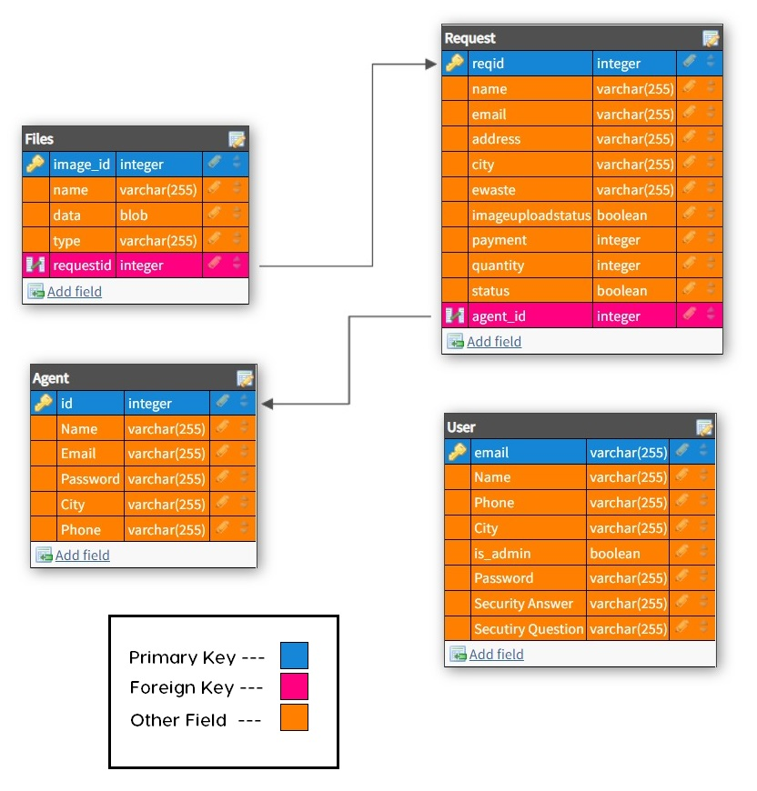

1. **Testing:**

**The report of the testing is given here under.**

**Test Cases**

|  |  |  |  |  |  |
| --- | --- | --- | --- | --- | --- |
| **Sr.**  **No** | **Test Case**  **Title** | **Description** | **Expected**  **Outcome** | **Error**  **Message** | **Result** |
| 1 | Login Page | User should see login page when user will enter email and password. | After signing in user to be directed to home page | Invalid Login | Passed |
| 2 | Home page  Displayed | Home page display for every  successful log in. | Home Page  Displayed | No Error | Passed |
| 3 | Donate Page | Users can add their request of e-waste by filling the details such  as quantity, description, images. | Request must be display in pending donation. | Validation error | Passed |
| 4 | View Donation page | Here, user can see his all completed donations. | User can check all his donations approved by admin | No Error | Passed |
| 5 | Profile | User can see all his details submitted to the company. | User can confirm all his details in card format. | No Error | Passed |
| 6 | Register | Should not allow any control to be empty if not null | If validated  Allow to go to login page | Validation Error | Passed |
| 7 | Forget Password | User allowed to reset password through verifying  email, security question and security answer | If validated allow to reset password | No error | Passed |
| 8 | Log Out | User should be able to logout from the website | User will logout and will be redirected to the Log in In page. | No Error | Passed |

1. **Project Management Methodology:**

Scrum Agile Methodology was used.

### 

### FUTURE SCOPE :

* 1. We will add buyers so that they can buy E-Waste and also provide payment gateway to the user so that he can also pay and accept through online mode.
  2. We will be adding feature for recycling companies to the website so that it will give more options to manage the e-waste.
  3. We will also give the order tracking functionality to the user.